Prevent, Mitigate, and Recover (PMR)

Collective Knowledge System (PICK)

User Documentation

Version 1.0

5/08/2020

**Document Control**

**Approval**

The Guidance Team and the customer shall approve this document.

**Document Change Control**

|  |  |
| --- | --- |
| Initial Release: | 1.0 |
| Current Release: | 1.5 |
| Indicator of Last Page in Document: | $$ |
| Date of Last Review: | 05/09/2020 |
| Date of Next Review: | 05/09/2020 |
| Target Date for Next Update: | 05/09/2020 |

**Distribution List**

This following list of people shall receive a copy of this document every time a new version of this document becomes available:

Guidance Team Members: Dr. Gates

Dr. Salamah

Dr. Roach

Elsa Tai Ramirez

Peter Hanson

Customer: Dr. Oscar Perez

Vincent Fonseca

Herandy Denisse Vazquez

Baltazar Santaella

Florencia Larsen

Erick De Nava

Software Team Members: Charlie Juarez

Miriam Juarez

Angelica Marquez

Andrew Munoz

Aaron Rodriguez

**Change Summary**

The following table details changes made between versions of this document

|  |  |  |  |
| --- | --- | --- | --- |
| Version | Date | Modifier | Description |
| 1.0 | 05/09/2020 | Angelica Marquez | Creation of Document |

**Table of Contents**

**DOCUMENT CONTROL II**

Approval ii

Document Change Control ii

Distribution List ii

Change Summary ii

**1.** **INTRODUCTION 1**

1.1. Purpose and Intended Audience 1

1.2. Scope of Product 1

1.3. References 1

1.4. Definitions, Acronyms, and Abbreviations 1

*1.4.1.* *Definitions 1*

*1.4.2.* *Acronyms 1*

*1.4.3.* *Abbreviations 1*

1.5. Overview 2

**2.** **Installation**

2.1. Software Configuration Item Organization 3

2.2. Dependencies 3

2.3. Running PICK 4

**3.** **Use Instructions 5**

3.1 Create a new PICK project 5

3.2 Validation and ingestion process 8

3.3 Navigation process 12

3.4 Vector table view 16

3.5 Graph view 16

# Introduction

## Purpose and Intended Audience

User Documentation reports how the system is used based on client requirements. The intended audience are the software engineers that will be maintaining the design and the analysts that will be using the software, supports future verification and maintenance.

## Scope of Product

The PMR Insight Collective Knowledge (PICK) System will facilitate the current node correlation process for analysts to complete their cyber security attack graphs. Currently, the analysis process takes months to complete and the system is needed to shorten the completion time to a more reasonable length. The system will save the analysts time with the automatization of log file processing along with filtering/searching functionality. The system’s attack graph creator component will further save analysts time and provide a flexible structure for analysts to work off of. The purpose of PICK is to retrieve and layout log information provided by the adversarial assessment. The software will ingest the log files to the analyst’s configuration and allow the analyst to produce attack graphs containing the events that transpired to provide a report for LSH.

## References

[1] S. Roach et al, Software Requirements Specification, Lethality, Survivability, and HSI Directorate (LSH),

2019.

## Definitions, Acronyms, and Abbreviations

### Definitions

|  |  |
| --- | --- |
| Log Entry | Splunk takes the validated log files and converts them into normalized data. The normalized data are called log entries. Users of the system can filter and edit log entries. |
| Timestamp | Denotes time in hours:minutes, date in month:date:year, and section in am/pm. |

### Acronyms

|  |  |
| --- | --- |
| PICK | PMR Insight Collective Knowledge |

### Abbreviations

|  |  |
| --- | --- |
| DB | Database |

## Overview

The User Documentation main focus is Installation and Use Instructions. Installation provides with the necessary dependencies for the program to run, also how to run PICK. It is important to follow the Dependencies to have your computer constructed to run PICK, this consist of Linux 0S, Python version 3 or higher, Team-Work GitHub repository, Splunk, PyQt5 and pymongo. Use instructions are a walkthrough over PICKS System. A series of pictures where it gives the user an image of what to expect and what are the tools provided to build a project. Use Instruction encapsulates how to create a PICK project, Validation and Ingestion Process, Navigation Process, Table Vector View, and Graph View.

# Installation

## 2.1 Software Configuration Item Organization

**2.1.1 Version Builds/Releases**

The versions of builds/releases of the PICK software will follow a standard with the only exception of the first

demo to the clients. Each of the versions will be traceable through the pushes made to the master branch of the

GitHub repository named ‘CS4311-spring-2020/pick-tool-team10-team-work’ will be tracked by the guidance

team members listed on the SRS document.

**2.1.2 Software Backups**

The system will not handle backups of the information as the customers have previously mentioned that the

information the software will handle is sensitive. Therefore, backing up the data could compromise their work.

Furthermore, there is no mention of backups on the SRS v7 document.

**2.1.3 Project Database**

The host device will contain a local database from which the software will be pulling data. Since there is nothing on the SRS v7 document relating to databases we are not using servers or connecting to

the internet. In the case of having multiple people working on the same project on the software a peer to peer communication will be established between the host device hosting the database and the other team members.

**2.2 Dependencies**

The following dependencies are necessary for PICK System to run on your computer. The resources listed are suggestions to set-up dependencies.

|  |  |  |
| --- | --- | --- |
| **Dependency** | **Comments** | **Resources** |
| Linux OS (Kali Linux/ Ubuntu Linux) | This program was run with Kali Linux and Ubuntu Linux. Running with other operating systems than Linux can not ensure the proper tool functionality of the program. | <https://ubuntu.com/download/desktop> |
| Python version 3 or higher | This program was created and run in version Python 3.8 | <https://www.python.org/downloads/release/python-380/>  <https://linuxize.com/post/how-to-install-python-3-8-on-ubuntu-18-04/> |
| Team-Work Github repository | Clone Github repository listed on resources | https://github.com/CS4311-spring-2020/pick-tool-team10-team-work.git |
| Splunk | Program run with version Splunk 8.0.3 | <https://www.splunk.com/>  <https://www.bitsioinc.com/tutorials/install-splunk-ubuntu/> |
| PyQt5 | Program run in python3-PyQt5 version 5.14.2 | <https://pypi.org/project/PyQt5/>  <https://pythonbasics.org/install-pyqt/> |
| pymongo | Program run with version pymongo 3.10.1 | <https://pypi.org/project/pymongo/> |

**2.3 Running PICK**

1. Make sure all the dependencies are installed.
2. Splunk has to be running in the background.
3. Run from the python folder inside the github repository (~/pick-tool-team10-team-work/python).
4. Run command python3 main.py

# 3. Use Instructions

**3.1 Create a new PICK project**

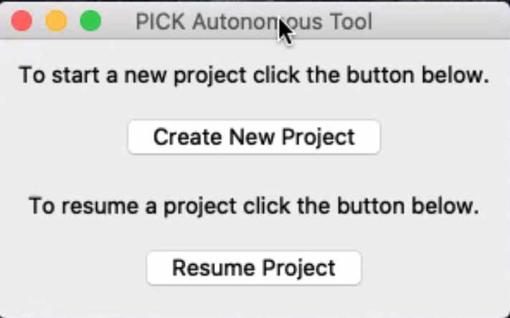

**Figure 1.0 Main window PICK Autonomous tool selected “Create New Project”**

1. Click Create New Project on the main window. You also have the option of resuming a project.

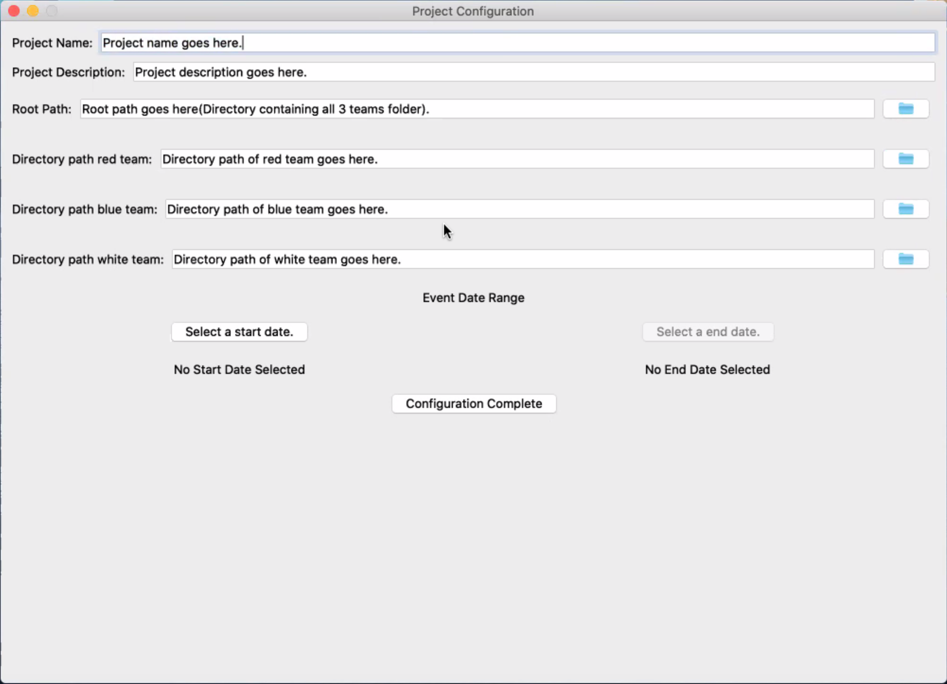

**Figure 2.0 Project Configuration Window**

2. Once the button for creating a new project has been pressed you will be taken on to the project config window in which you will be presented with the information the program needs to start a new project.

## 

Write “Project Description”

Write “Project Name”

Select start and end date from the drop-down calendar.

Select directory by clicking at the folder icon.

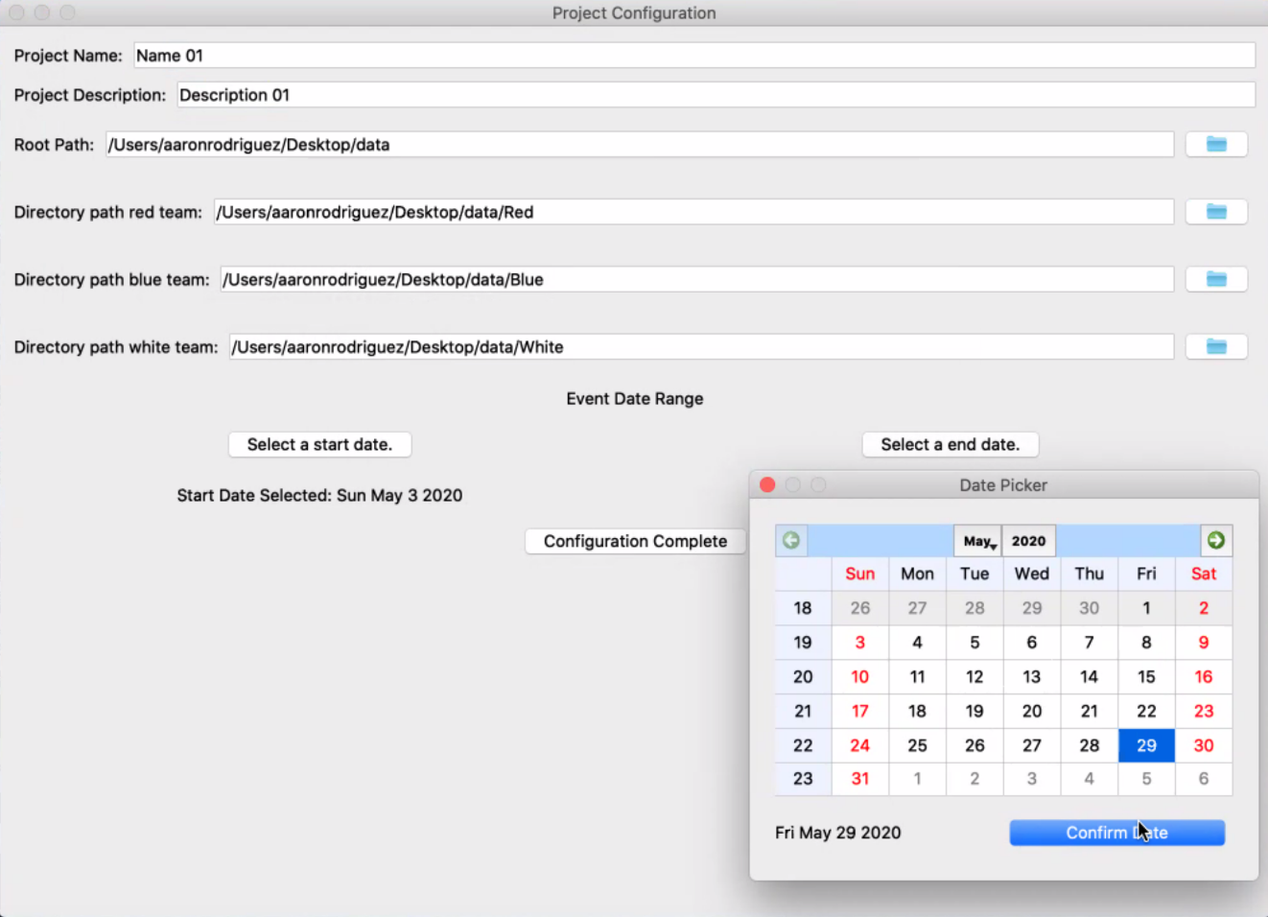

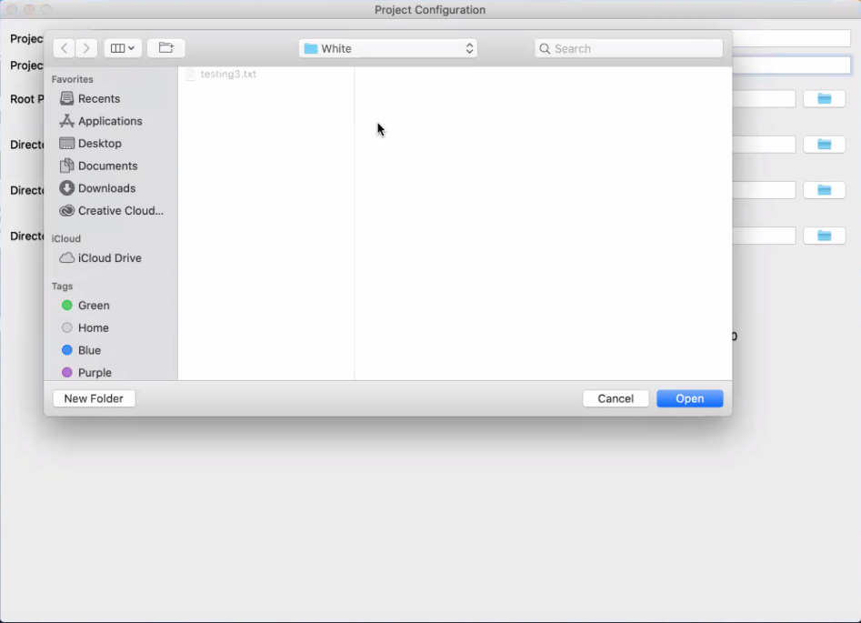

**Figure 2.1 Project Configuration Window with filled values**

3. The first line entry will be to input a name for the project followed by second line entry for a description of the project.

**Note:** This step is optional for creating the project but can be useful for the user as a way to be reminded of what’s being worked on. This information will be stored in a file inside the Data folder.

4. The third line entry is for putting the directory which will be containing the three folders for the Red, Blue, and White team. If you do not want to type in the directory there will be a file chooser button if you want to use a file chooser window to select the directory, once selected the directory path will be automatically inserted into the line entry.

5. The fourth, fifth, and sixth line entries are for selecting the directory to the Red, Blue, and White containing their team’s respective log files. In which the directory path can be put in manually or automatically by pressing the file chooser button in the same fashion as the third line entry.

**Note:** It is critical that the names of the respective teams folder are named exactly as follows; “Red”, “Blue”, “White”. It is also important to note that hidden files will be selected from these folders as well, therefore getting rid of them before continuing is crucial for the program to work, if not the program will crash when trying to cleanse/validate them.

6. You will then be required to select a time range from which files are to be selected for possible ingestion into the system. The button for selecting a start date will be used for selecting the earliest date from which a log file can be considered for ingestion, after selecting a date the selected date will be displayed under the select a start date button.

7. Once a start date has been selected, you will now be able to select an end date as this will be used for selecting the latest date from which a log file can be considered for ingestion, after selecting a date the selected date will displayed under the select a end date button.

**Note:** It is important to note that when a date is being selected, make sure to click on the date as it will have a date selected automatically on the calendar upon opening the window however a date will never be saved unless the date on the calendar is clicked.

8. Once the data on this window is filled out click on the configuration complete button to proceed onto the validation and ingestion window.

**3.2 Validation and Ingestion Process**

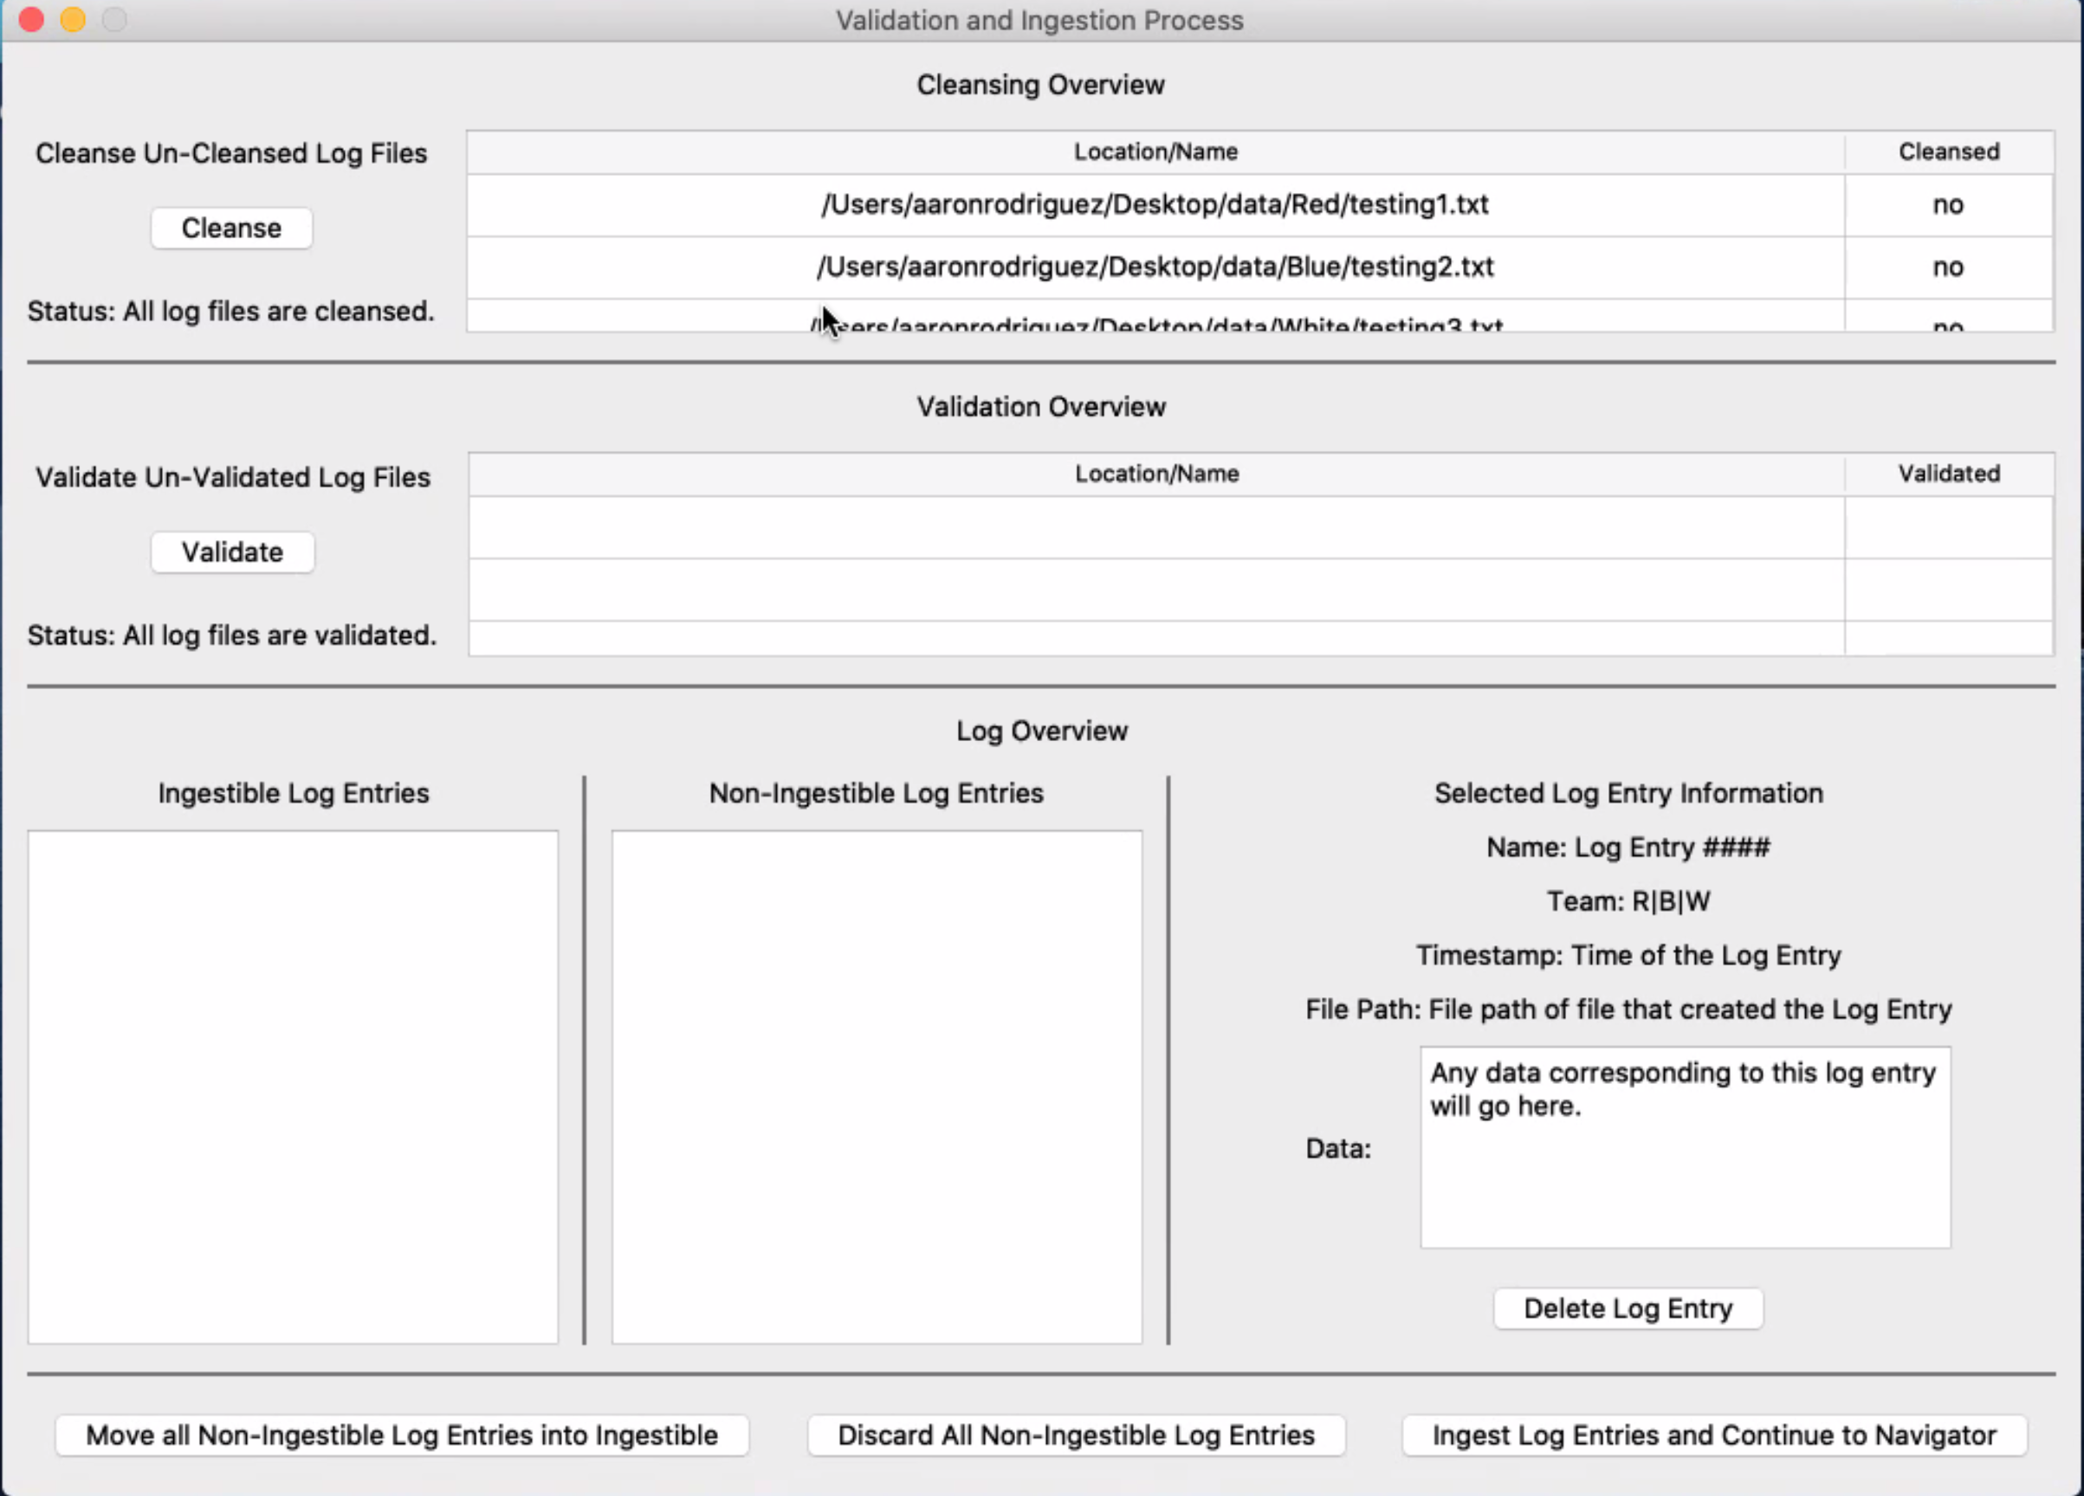

Figure 3.1 Validation and Ingestion Process Window

1. When the validation and ingestion window appears the log files within the team folders that fall within the date range specified in the project configiguration window will appear under the cleansing table.

## 

Figure 3.2 Validation and Ingestion Process Window after selecting cleanse button

2. Click on the cleanse button as this will run the cleansing script on the file getting rid of unreadable characters. Figure 3.1 Once the files have been cleansed they will appear on the validate table. Figure 3.2

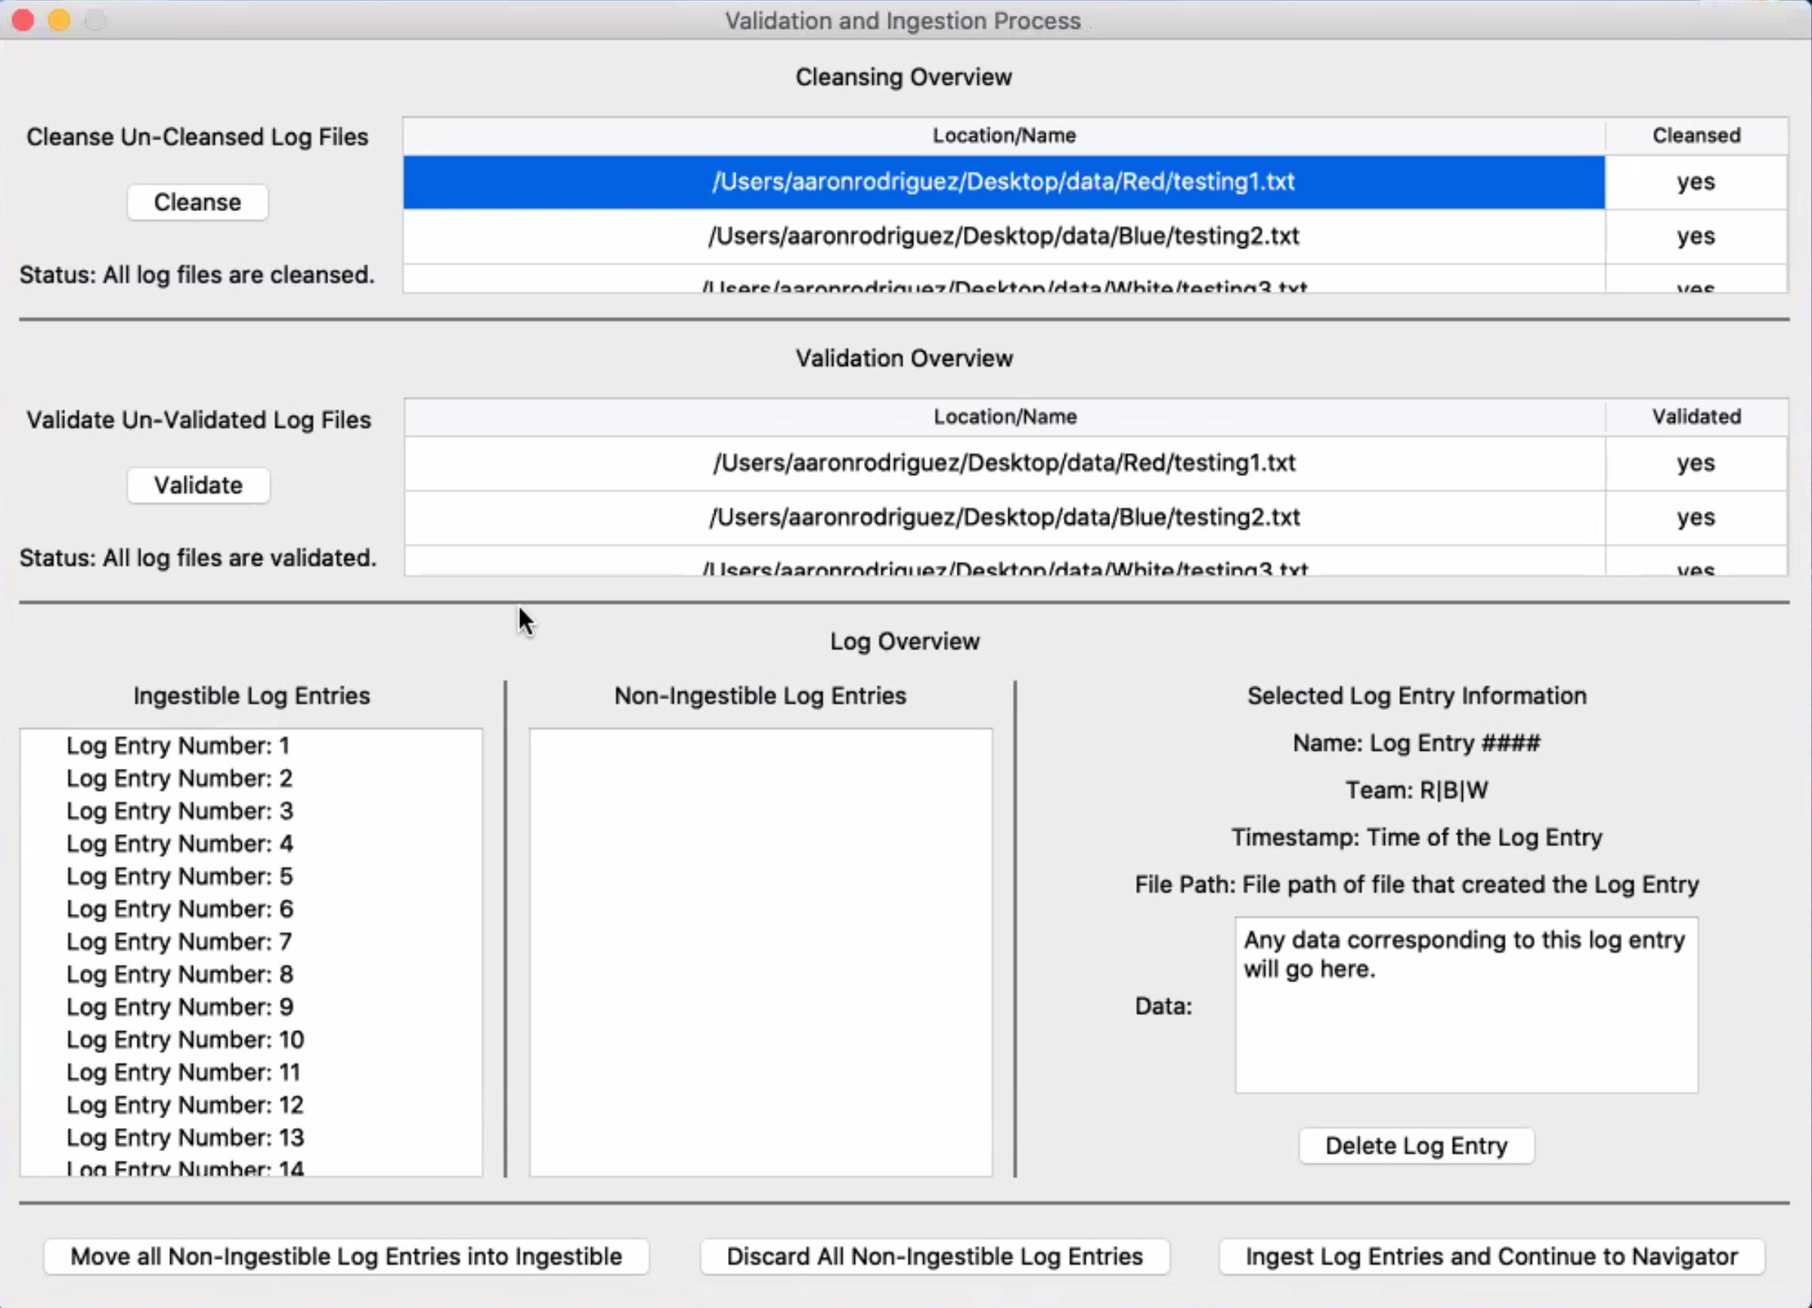

Figure 3.3 Validation and Ingestion Process Window

3. The next step is to click on the validate button as this will upload the log files to Splunk, which will ask for your credentials first before uploading in the terminal. Once the files are uploaded to Splunk, as they take up some time, the log entries will be retrieved from Splunk’s database and displayed on the ingestible list on the left hand side. You can click on the list values to display the log entries on the right hand side

**Note:** When retrieving the log entries from Splunk there will be an unsecure warning displayed but will not affect the program in any way.

**Note:** As of the creation of this document there are no non-ingestible log entries, as any log files that are attempted to be uploaded to Splunk will cause the program to crash.)

## 

## Figure 2.4 Validation and Ingestion Process Window showing information at “Selected Log Entry Information”

## 4. If you select a Log Entry at “Ingestible Log Entries” you can see the Log Entry information at the Left hand side Figure 2.4

## 5. Select the button “Ingest Log Entries and Continue to Navigator” to change window view into Navigation Process

**3.3 Navigation Process**

## 3.3.1 Filter Configuration

## 

Figure 3.1 Log Entry Configuration Add Filter

## 

1. On the Filter Configuration you have the option to filter by a range of time. Select “Add Time Filter” a new filter will appear. Figure 3.1 Select the filter and you will be able to Name, choose a Star Time and choose an End Time. Next, press “Ok” to save your filter. Figure 3.2

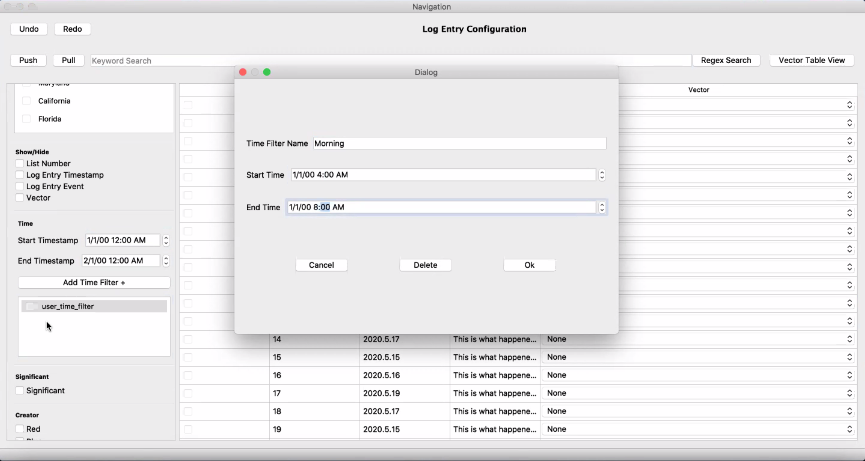

Figure 3.2 Log Entry Configuration Add Filter

3.3.2 Vector Configuration

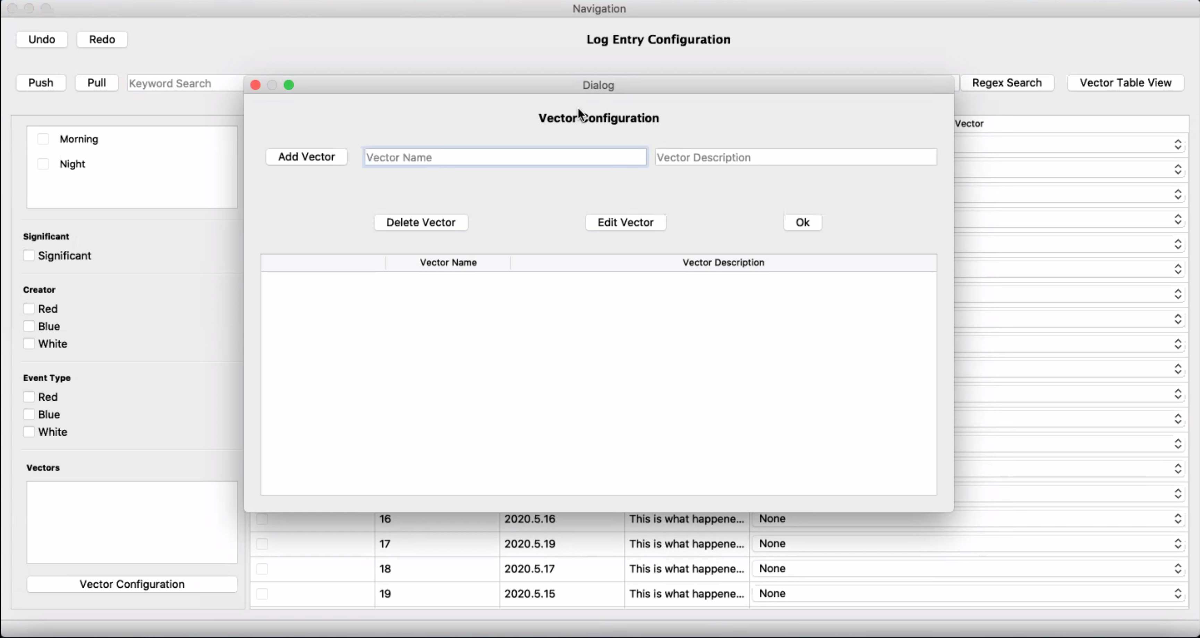

Figure 3.3 Log Entry Configuration, Vector Configuration Window

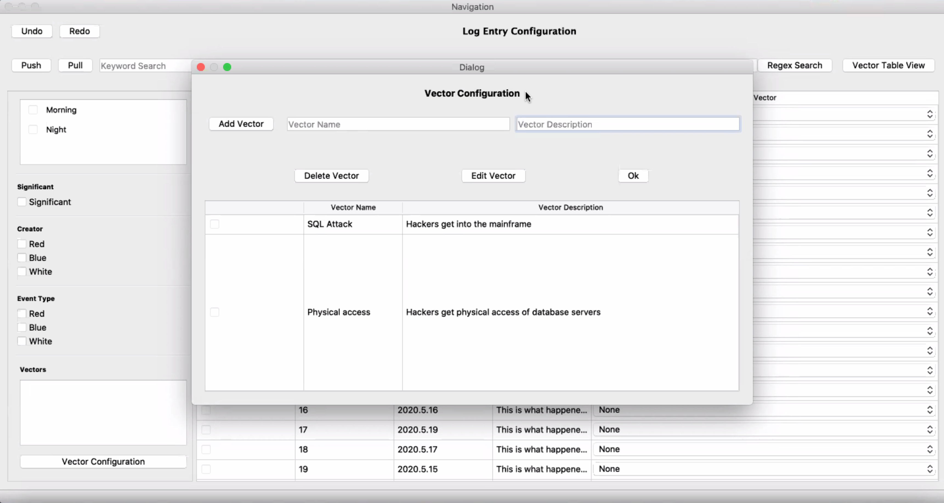

Figure 3.3 Log Entry Configuration, Vector Configuration Window with vector examples

2. At PICK you have the ability to add Vectors. Select “Vector Configuration” to Add, Delete, and Edit Vectors. Write Name and Description.

## 

Figure 3.4 Log Entry Configuration, Log entry Vector selection

3. In the Log Entry Configuration table you can select the appropriate vector for each log entry.

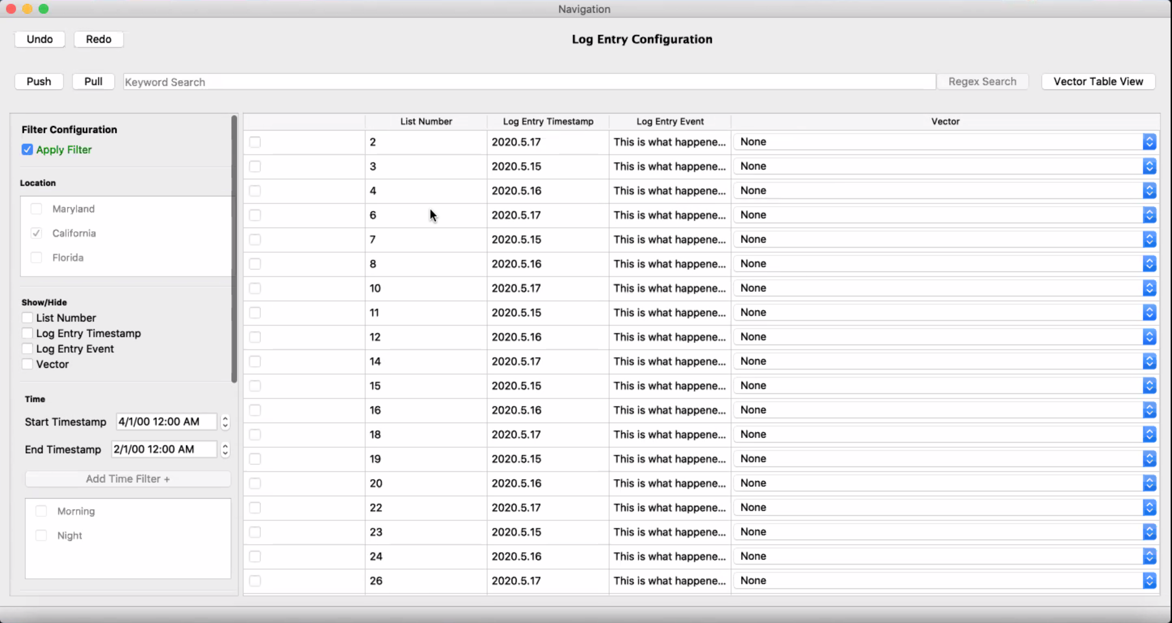

Figure 3.5 Log Entry Configuration, Apply Filter

4. After selecting all your desired filter, options are “Location”, “Show/Hide”, “Time”, “Significant”, “Creator”, “Event Type” and/or “Vectors”, click on “Apply Filter” to perform your filtering.

3.3.2 Regex

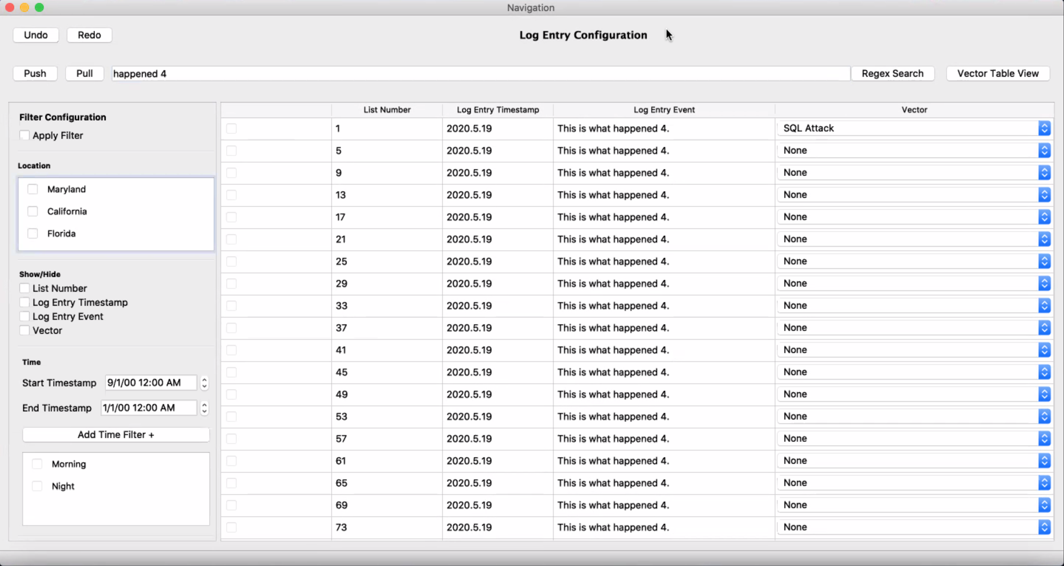

Figure 3.5 Log Entry Configuration Search

4. Write on the search bar and click Regex. This will search on the log entries, you can see the result filtering on column “Log Entry Event”. 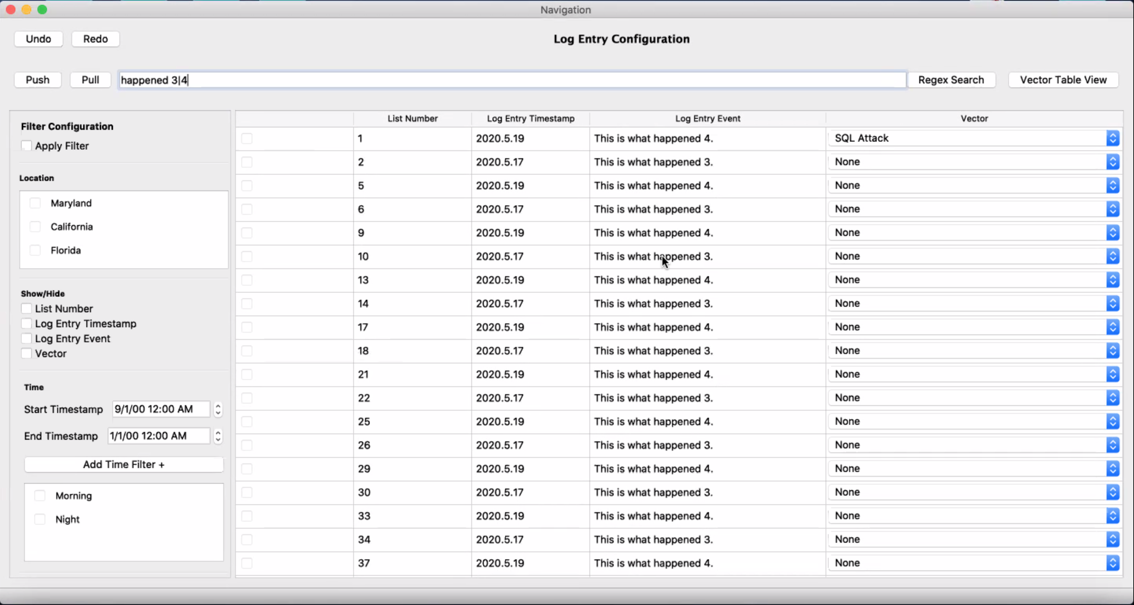Figure 3.6 Regex search can also look by OR function with the symbol “|”.

## 

Figure 3.7 Vector Table View, select View Graph

**3.4 Graph View**

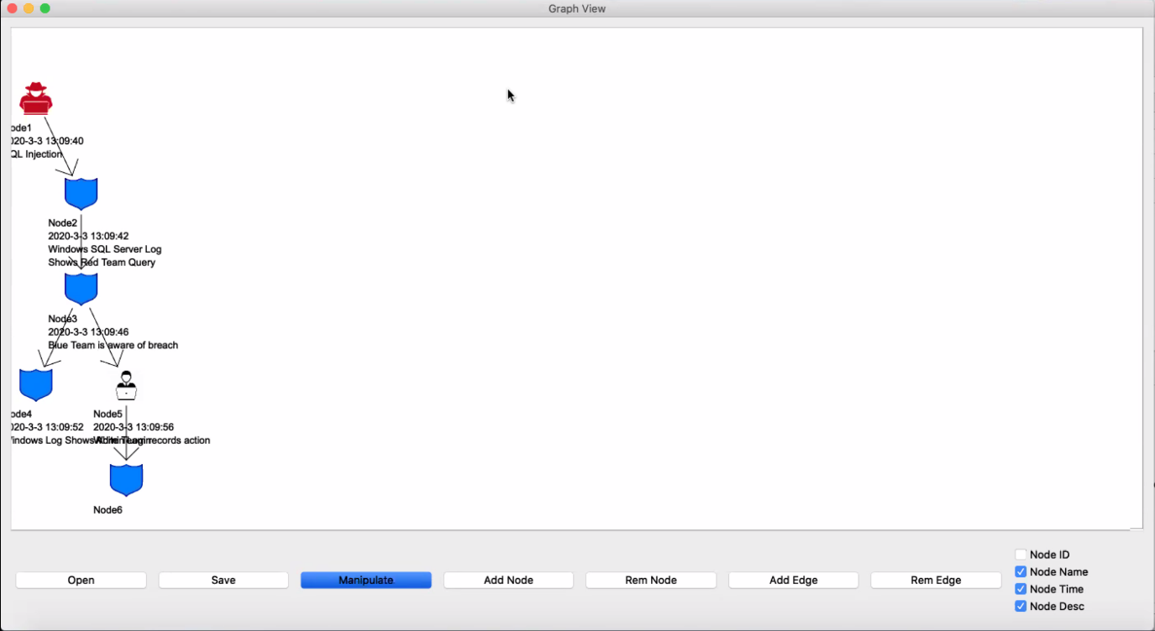  
Figure 4.1 Graph View

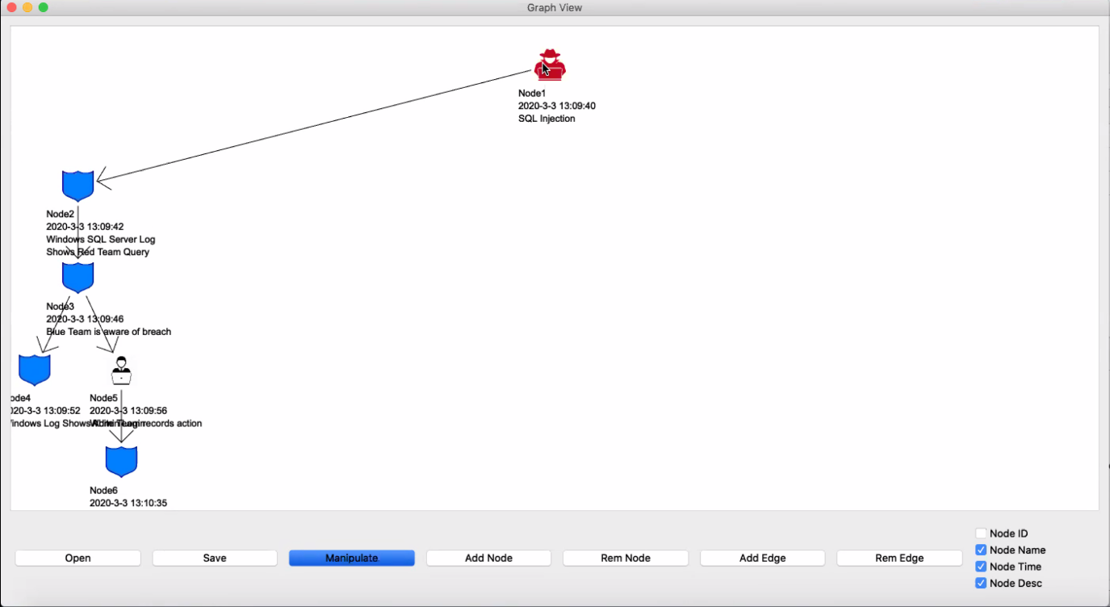

Figure 4.1 Graph View

1. Move the nodes by selecting it and grabbing to the desired position

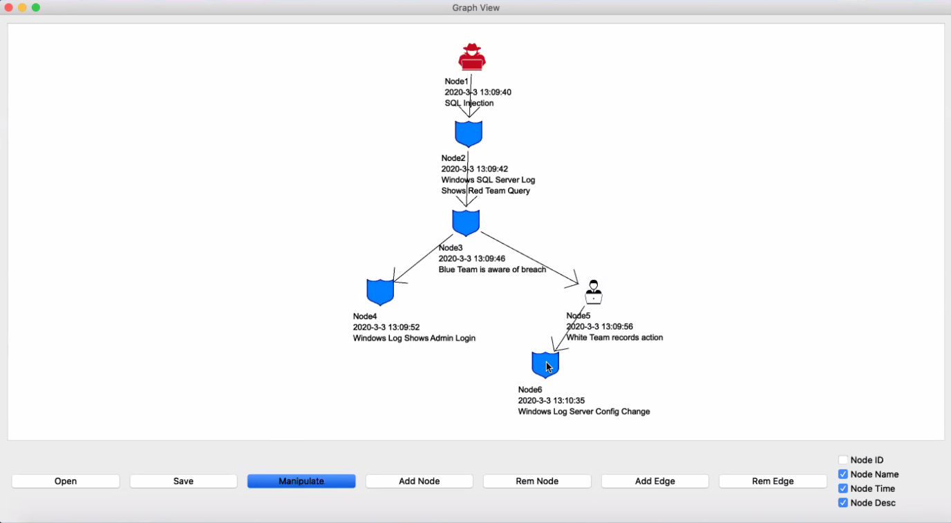

Figure 4.1 Graph View Organized

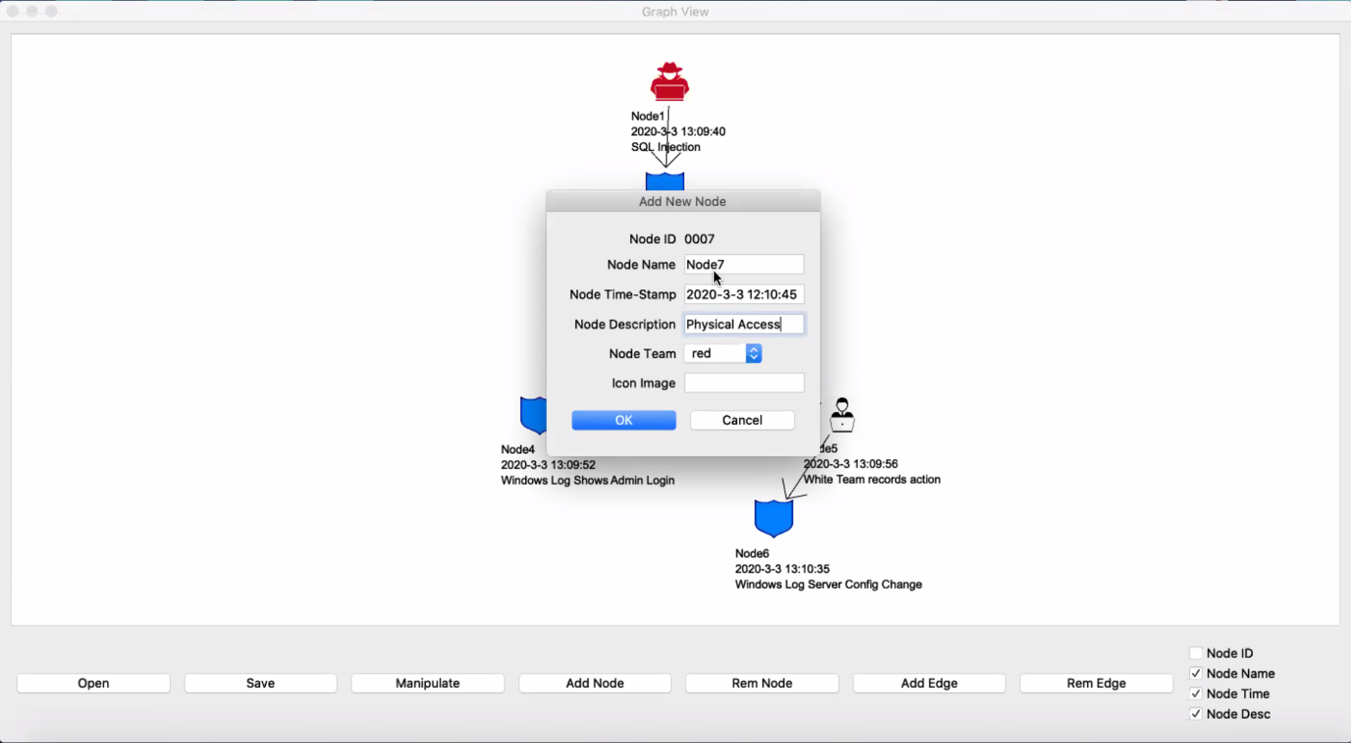

Figure 4.1 Graph View, Add New Node Window

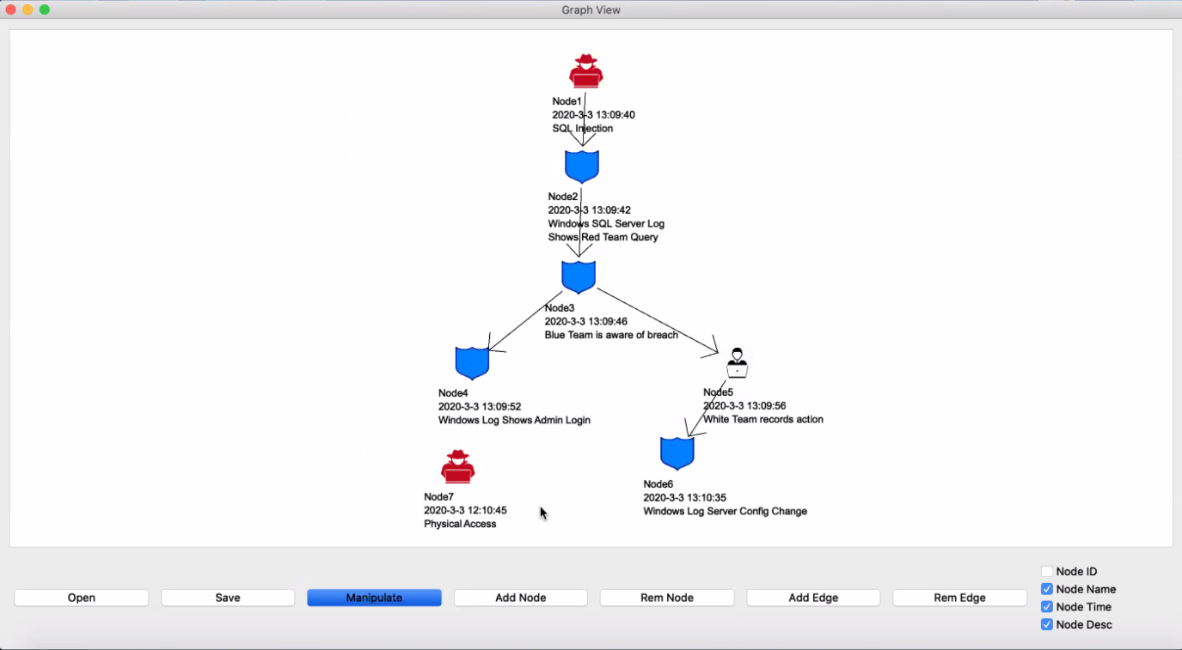

Figure 4.2 Graph View, New node added

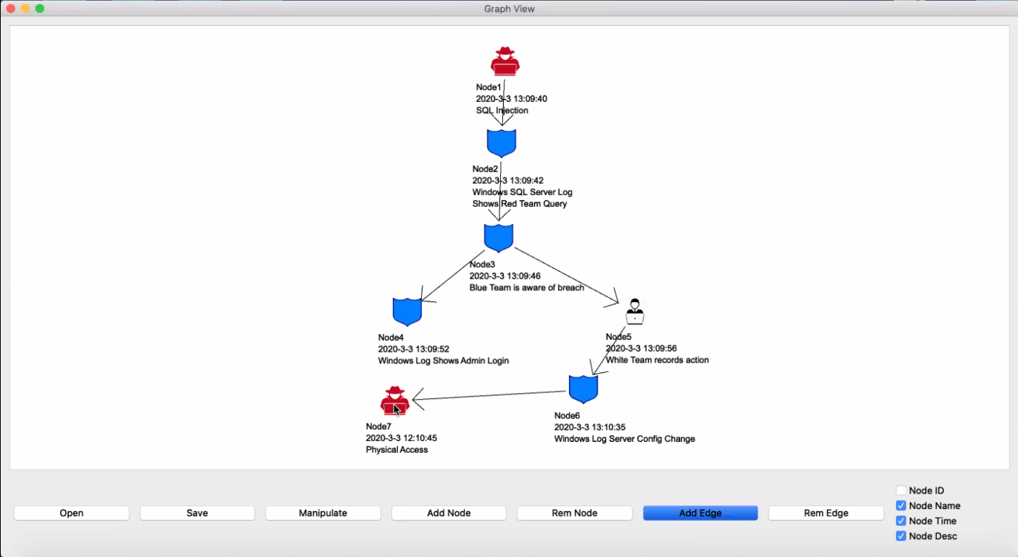

Figure 4.3 Graph View, Add Edge

2. To add a new edge select the button “Add Edge” then select the origin node and directed to the destination node

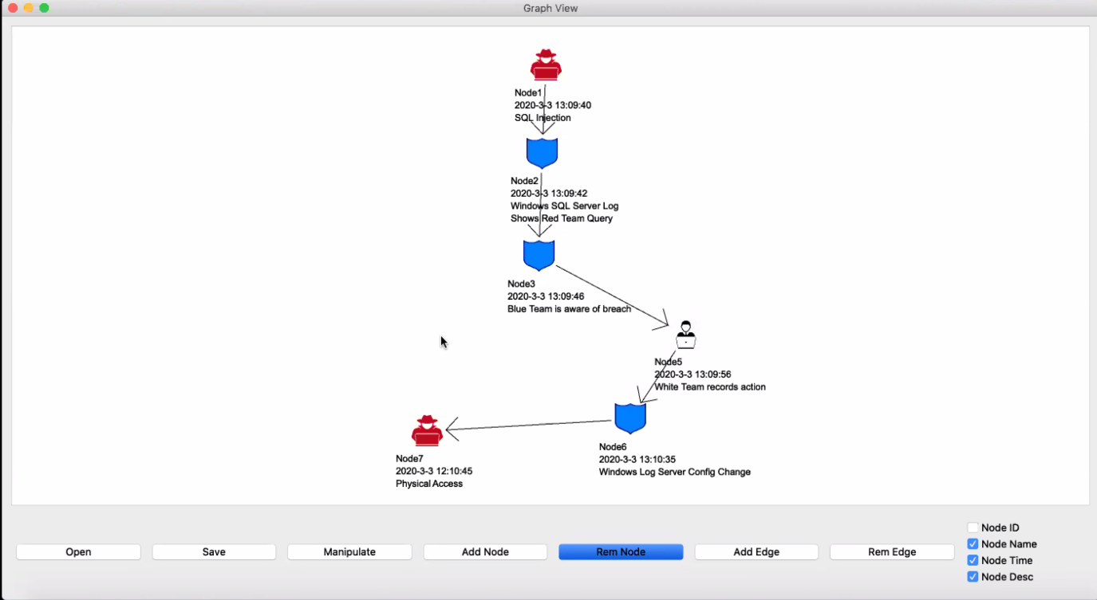

Figure 4.4 Graph View, Remove Node

3. To remove node, select “Remove Node”, then click on the Node you want to remove.

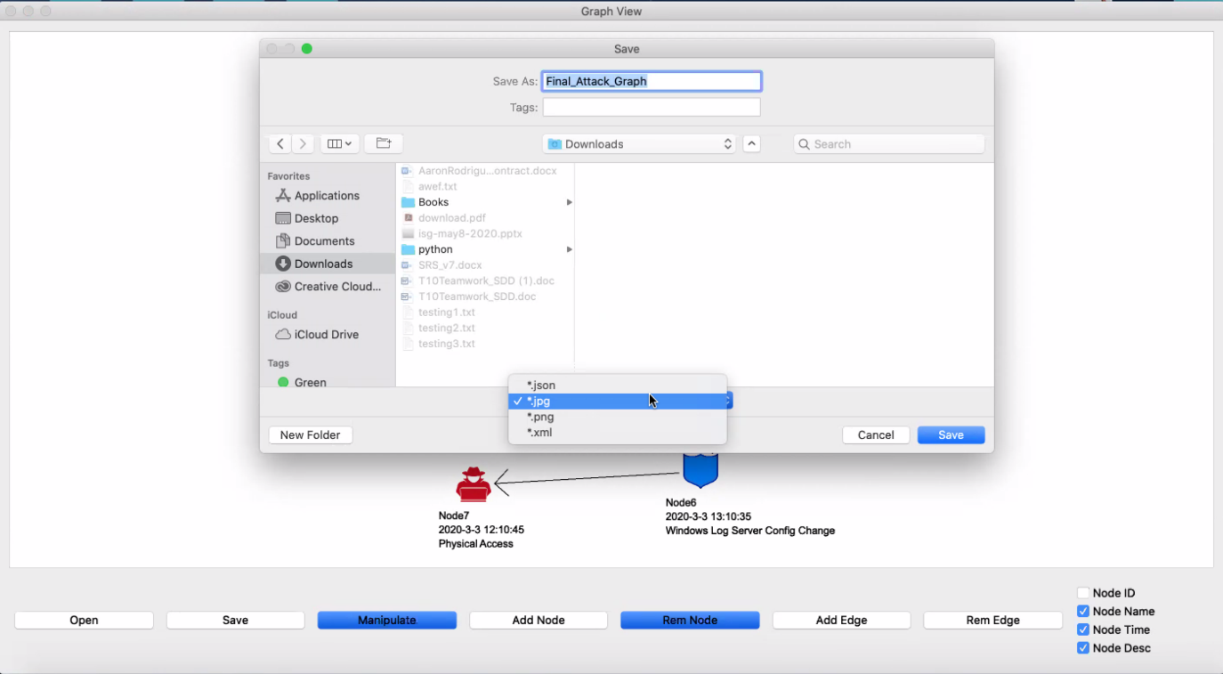

Figure 4.5 Graph View, Save Window

4. To save a project on Graph View select “Save”, then the save window will display, select the format you want to save. PICK projects can be saved on JASON, JPG, PNG, XML format.

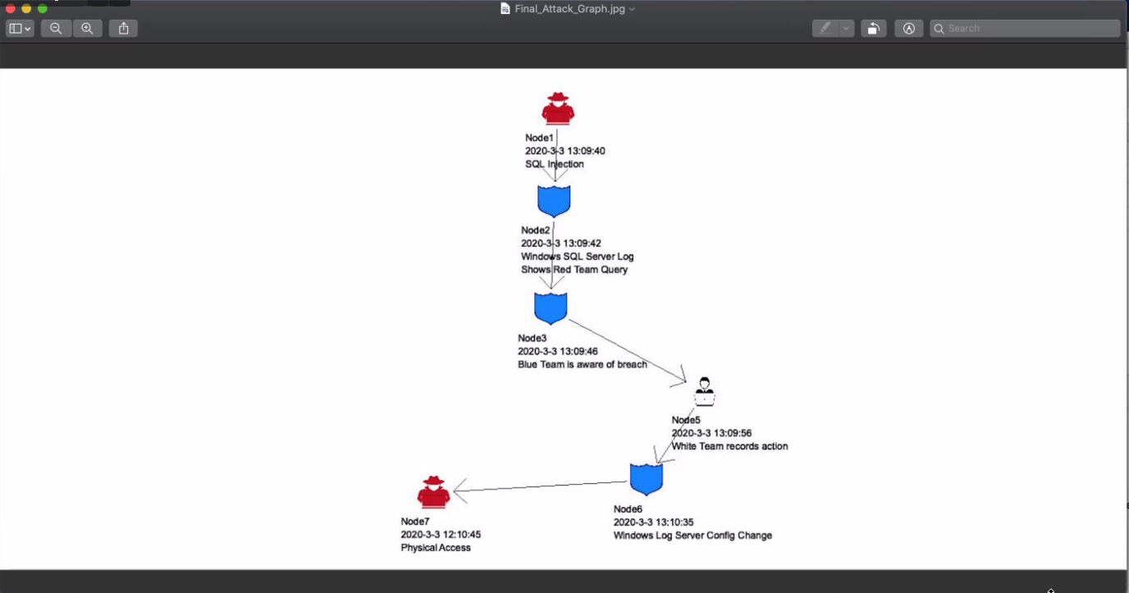

Figure 4.6 JPG Sample

$$$$$